

NAME: BISMA FATIMA
CLASS: CS A
ROLL NO: F24605036
COURSE: ARTIFICIAL INTELLIGENCE
COURSE CODE: CS-281
LECTURER: SIR IJLAL HAIDER

ESE

QUESTION NO 01:
# Leaf values from left to right
leaf_values = [5, 7, 1, -2, -8, -4, 3, 7, -9, 2, 3, 1, -5, 8, 2]

# Track pruned values
pruned_values = []

def alpha_beta(depth, index, is_maximizing, alpha, beta):
# Base case: leaf node
if depth == 4:
return leaf_values[index]

if is_maximizing:
max_eval = float('-inf')
for i in range(2):
child_index = index * 2 + i
eval = alpha_beta(depth + 1, child_index, False, alpha, beta)
max_eval = max(max_eval, eval)
alpha = max(alpha, eval)
if beta <= alpha:
# Prune remaining children
if i == 0:
pruned_values.append(leaf_values[child_index + 1])
break
return max_eval
else:
min_eval = float('inf')
for i in range(2):
child_index = index * 2 + i
eval = alpha_beta(depth + 1, child_index, True, alpha, beta)
min_eval = min(min_eval, eval)
beta = min(beta, eval)
if beta <= alpha:
# Prune remaining children
if i == 0:
pruned_values.append(leaf_values[child_index + 1])
break
return min_eval

# Run Alpha-Beta Pruning from root
optimal_value = alpha_beta(0, 0, True, float('-inf'), float('inf'))

# Output results
print(f"Optimal value at root node: {optimal_value}")
print(f"Pruned values: {pruned_values}")

OUTPUT

QUESTION NO 02:
import pandas as pd
import numpy as np
import matplotlib.pyplot as plt
import seaborn as sns
from sklearn.model_selection import train_test_split
from sklearn.preprocessing import StandardScaler
from sklearn.linear_model import LogisticRegression
from sklearn.tree import DecisionTreeClassifier
from sklearn.ensemble import RandomForestClassifier
from sklearn.svm import SVC
from sklearn.neighbors import KNeighborsClassifier
from sklearn.metrics import accuracy_score, precision_score, recall_score, f1_score
from sklearn.metrics import classification_report, confusion_matrix, ConfusionMatrixDisplay
import warnings
warnings.filterwarnings('ignore')

# =====================================
# 1. Load and Explore the Dataset
# =====================================
df = pd.read_csv('/heart_disease_dataset - heart_disease_dataset.csv') # adjust path if needed

print("Dataset Shape:", df.shape)
print("\nColumns and Data Types:")
print(df.dtypes)
print("\nMissing Values:")
print(df.isnull().sum())

# Summary statisti
print("\nSummary Statistics:")
print(df.describe().round(2))

# Target variable distribution
print("\nClass Distribution (Outcome):")
print(df['num'].value_counts(normalize=True).round(3))

# =====================================
# 2. Visualizations
# =====================================
# Histograms of numerical features
df[['age','trestbps','chol','thalch','oldpeak']].hist(figsize=(12, 10), bins=20, color='skyblue', edgecolor='black')
plt.suptitle('Distribution of Numerical Features', y=1.02)
plt.show()

# Pairplot
sns.pairplot(df, hue='num', vars=['age','trestbps','chol','thalch','oldpeak'], palette='viridis')
plt.suptitle('Feature Relationships by Heart Disease Outcome', y=1.02)
plt.show()

# Correlation heatmap
plt.figure(figsize=(10, 8))
sns.heatmap(df.corr(), annot=True, cmap='coolwarm', fmt='.2f', linewidths=0.5)
plt.title('Correlation Heatmap')
plt.show()

# =====================================
# 3. Preprocessing
# =====================================
X = df.drop('num', axis=1)
y = df['num']

# Train-test split (stratified to preserve class balance)
X_train, X_test, y_train, y_test = train_test_split(X, y, test_size=0.2, random_state=42, stratify=y)

# Feature scaling (important for SVM, KNN, Logistic Regression)
scaler = StandardScaler()
X_train_scaled = scaler.fit_transform(X_train)
X_test_scaled = scaler.transform(X_test)

# =====================================
# 4. Classification Models
# =====================================
models = {
'Logistic Regression': LogisticRegression(max_iter=1000, random_state=42),
'Decision Tree': DecisionTreeClassifier(max_depth=5, random_state=42),
'Random Forest': RandomForestClassifier(n_estimators=200, max_depth=10, random_state=42),
'SVM': SVC(kernel='rbf', probability=True, random_state=42),
'KNN': KNeighborsClassifier(n_neighbors=7)
}

results = []

for name, model in models.items():
# Use scaled data for models that need it
if name in ['Logistic Regression', 'SVM', 'KNN']:
model.fit(X_train_scaled, y_train)
y_pred = model.predict(X_test_scaled)
else:
model.fit(X_train, y_train)
y_pred = model.predict(X_test)

acc = accuracy_score(y_test, y_pred)
prec = precision_score(y_test, y_pred, average='macro')
rec = recall_score(y_test, y_pred, average='macro')
f1 = f1_score(y_test, y_pred, average='macro')

results.append({
'Model': name,
'Accuracy': round(acc, 3),
'Precision': round(prec, 3),
'Recall': round(rec, 3),
'F1-Score': round(f1, 3)
})

# Classification Report & Confusion Matrix
print(f"\n=== {name} ===")
print(classification_report(y_test, y_pred))

cm = confusion_matrix(y_test, y_pred)
disp = ConfusionMatrixDisplay(confusion_matrix=cm, display_labels=['No Disease', 'Disease'])
disp.plot(cmap='Blues')
plt.title(f'Confusion Matrix - {name}')
plt.show()

# =====================================
# 5. Results Table
# =====================================
results_df = pd.DataFrame(results)
print("\n=== Model Performance Comparison ===")
print(results_df.sort_values('F1-Score', ascending=False))

# =====================================
# 6. Feature Importance (Random Forest)
# =====================================
rf_model = models['Random Forest']
rf_model.fit(X_train, y_train)

feat_imp = pd.Series(rf_model.feature_importances_, index=X.columns).sort_values(ascending=False)

plt.figure(figsize=(10, 6))
sns.barplot(x=feat_imp.values, y=feat_imp.index, palette='viridis')
plt.title('Feature Importance - Random Forest')
plt.xlabel('Importance Score')
plt.show()

# =====================================
# 7. Key Insights
# =====================================
print("\n=== Key Insights ===")
print("Top 5 most important features:")
print(feat_imp.head(5))

best_model = results_df.loc[results_df['F1-Score'].idxmax()]
print(f"\nBest performing model: {best_model['Model']}")
print(f"Accuracy = {best_model['Accuracy']}, F1-Score = {best_model['F1-Score']}")

print("\nWhy it performs well:")
print("- Random Forest usually wins because it handles non-linear relationships and interactions well.")
print("- It is robust to outliers and less prone to overfitting than a single Decision Tree.")
print("- It provides reliable feature importance.")
print("\nKey predictors of heart disease:")
print("- age, cholesterol, maximum heart rate (thalch), resting blood pressure (trestbps), and ST depression (oldpeak)")

OUTPUT
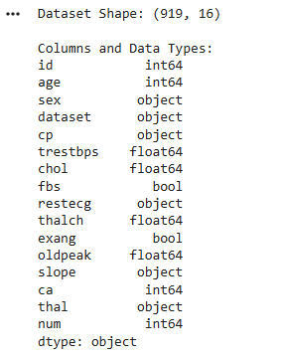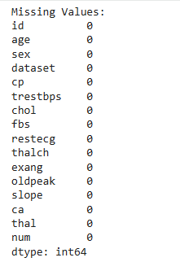
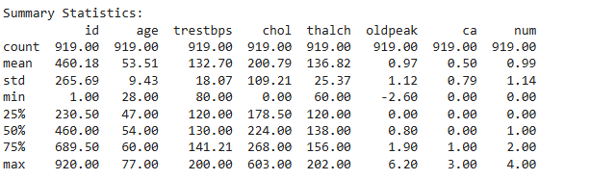
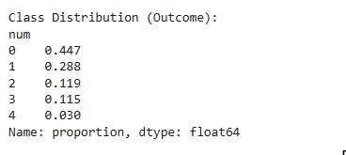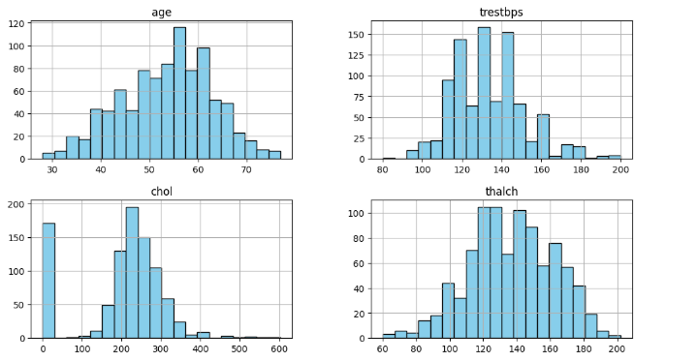
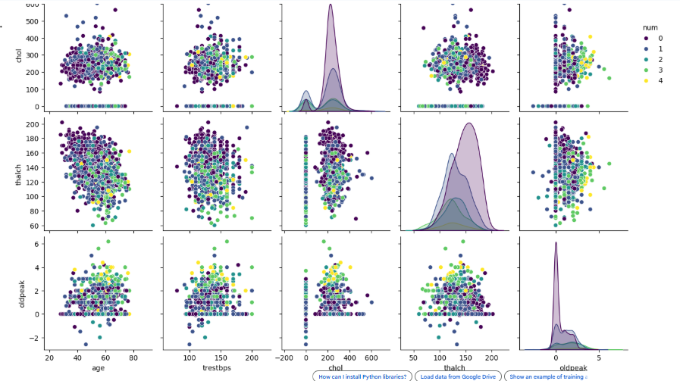
QUESTION NO 03:
# Install pgmpy if not already installed:
# pip install pgmpy
from pgmpy.models import DiscreteBayesianNetwork
from pgmpy.factors.discrete import TabularCPD
from pgmpy.inference import VariableElimination

# 1. Define the network structure
model = BayesianNetwork([
('Discount', 'Browsing'),
('Product', 'Browsing'),
('Discount', 'Purchase'),
('Product', 'Purchase'),
('Browsing', 'Purchase')
])

# 2. Define CPDs (Conditional Probability Distributions)

# Discount prior
cpd_discount = TabularCPD(
variable='Discount',
variable_card=2,
values=[[0.6], [0.4]], # available, unavailable
state_names={'Discount': ['available', 'unavailable']}
)

# Product prior
cpd_product = TabularCPD(
variable='Product',
variable_card=2,
values=[[0.7], [0.3]], # high, low
state_names={'Product': ['high', 'low']}
)

# Browsing given Discount (currently ignoring Product for simplicity)
cpd_browsing = TabularCPD(
variable='Browsing',
variable_card=3,
values=[
[0.5, 0.2], # high
[0.3, 0.4], # medium
[0.2, 0.4] # low
],
evidence=['Discount'],
evidence_card=[2],
state_names={'Browsing': ['high', 'medium', 'low'],
'Discount': ['available', 'unavailable']}
)

# Purchase given Browsing, Discount, Product
cpd_purchase = TabularCPD(
variable='Purchase',
variable_card=2,
values=[
# P(Purchase = yes | Browsing, Discount, Product)
[0.9, 0.8, 0.7, 0.6, 0.5, 0.4,
0.7, 0.6, 0.5, 0.4, 0.3, 0.2],
# P(Purchase = no | Browsing, Discount, Product)
[0.1, 0.2, 0.3, 0.4, 0.5, 0.6,
0.3, 0.4, 0.5, 0.6, 0.7, 0.8]
],
evidence=['Browsing', 'Discount', 'Product'],
evidence_card=[3, 2, 2],
state_names={
'Purchase': ['yes', 'no'],
'Browsing': ['high', 'medium', 'low'],
'Discount': ['available', 'unavailable'],
'Product': ['high', 'low']
}
)

# 3. Add CPDs to the model
model.add_cpds(cpd_discount, cpd_product, cpd_browsing, cpd_purchase)

# 4. Check if the model is valid
print("Model is valid:", model.check_model())

# 5. Perform inference
inference = VariableElimination(model)
prob_purchase = inference.query(variables=['Purchase'], evidence={'Discount': 'available'})
print(prob_purchase)

OUTPUT

